Topic – Analysis and Development of Linear Search Algorithm

Tripti Vishwakarma
Colorado State University Global
Course Code: CSC 506 -1
Dr. Dong Nguyen
Nov 17, 2014

Title: Analysis and Development of a Linear Search Algorithm
Introduction
Linear search is one of the most fundamental algorithms in computer science, often serving as an introductory exercise in learning how to search through data structures. Despite its simplicity, linear search remains relevant in scenarios where datasets are unsorted or small, and where ease of implementation is prioritized. This paper discusses the purpose of developing a linear search program, analyzes its efficiency and applicability, and reflects on the skills gained through the development process.

Linear Search Algorithm
Here's a complete implementation of the linear search algorithm in Python:

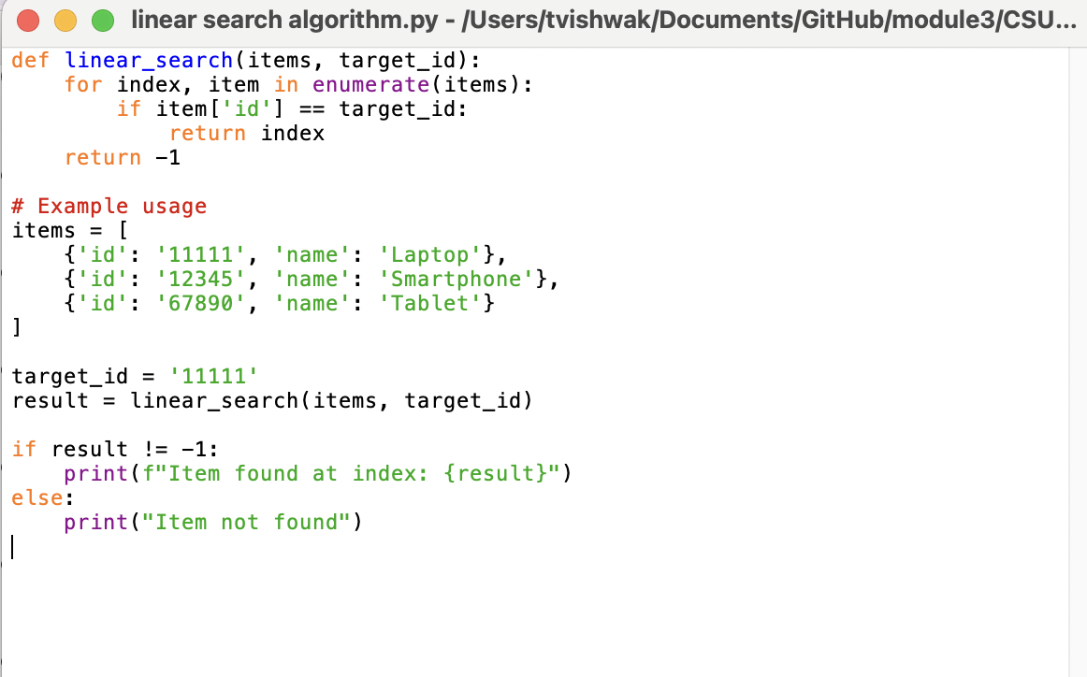

Successful implementation of the program-

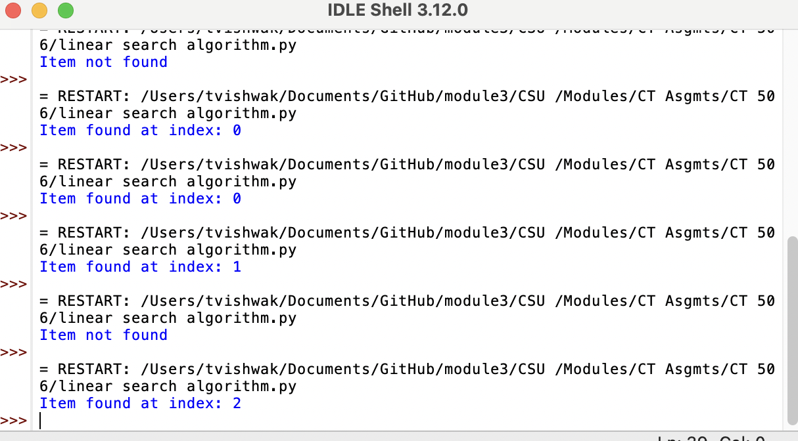

Program Purpose and Applicability
The primary purpose of creating a linear search program is to offer a straightforward approach to searching elements in a dataset. Linear search is particularly useful when the dataset is unsorted and small, or when computational simplicity is more critical than efficiency. It provides an excellent learning platform for beginners to grasp the basic concepts of search algorithms and understand their applications in unsorted data contexts.

Time Complexity and Data Structure Impact
The time complexity of a linear search is O(n), where n represents the number of elements in the dataset. In the context of online searches, especially within unsorted datasets, linear search provides a consistent and predictable solution. Its performance is directly influenced by the data structure employed. In arrays or lists, linear search allows for efficient implementation due to direct element access. However, in linked lists, the absence of indexed access can make the search slower, affecting performance.

External Factors Influencing Performance
Several external factors can influence the lower bound and overall performance of a linear search:
- Data Distribution: If the target element frequently appears near the start of the dataset, the average time complexity can be significantly reduced.
- Hardware Limitations: Processor speed and memory access times can directly impact search execution times, especially in larger datasets.
- Concurrent Processing: In multi-threaded environments, managing concurrent data access can introduce additional complexity, potentially affecting the algorithm's efficiency.

Challenges and Skills Acquired
Developing the linear search algorithm involved addressing challenges such as ensuring accuracy across different datasets and managing edge cases like missing elements. These challenges provided a platform for enhancing Python programming skills, particularly in using control structures effectively. Additionally, the project improved problem-solving skills and debugging practices, emphasizing the importance of writing clean and maintainable code.

Conclusion
The development and application of a linear search algorithm provide critical insights into algorithmic efficiency and foundational programming skills. While linear search may not be the most efficient for large datasets, its simplicity makes it an invaluable educational tool. The skills acquired during this development process are essential for advancing in computer science and tackling more complex algorithms in the future.

References
Cormen, T. H., Leiserson, C. E., Rivest, R. L., & Stein, C. (2009). Introduction to Algorithms (3rd ed.). MIT Press.
https://drive.google.com/file/d/0B3RHrbxFb7PfYjk4ZG01Z3lrbnc/view?resourcekey=0-aHyhqxUeXCNvRK3_QfNurg

Sedgewick, R., & Wayne, K. (2011). Algorithms (4th ed.). Addison-Wesley Professional
https://drive.google.com/file/d/0B9_PJNHU4_-dcTJLOHJjQkZrbDg/view?resourcekey=0-G7JAF1EIgOcdoQR4hfOcEw
Tutorialspoint Data structures- Algorithm Basics https://www.tutorialspoint.com/data_structures_algorithms/algorithms_basics.htm

